# Baobab

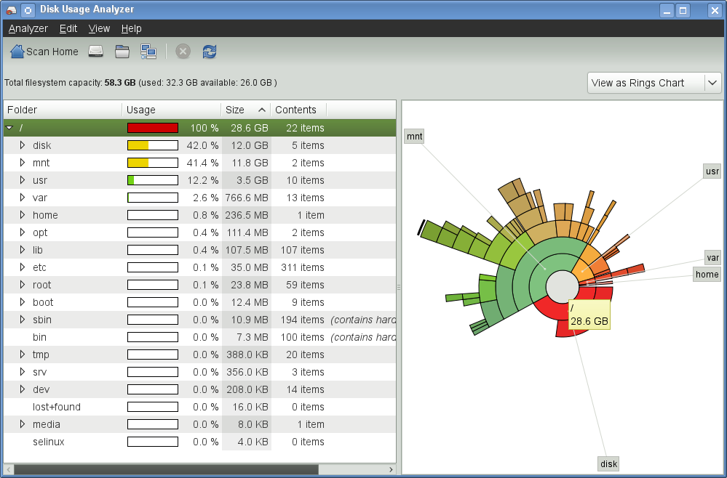

* Real-time refresh
* scan the whole file system or a specific folder
* Efficient GUI
  + rings with relative sizes and colors
  + navigate through file tree map from both user interfaces
  + Shows details of the folders
    - usage % of parent directory
    - Folder Name
    - Size
    - number of contents
* Disadvantages:
  + Does not show files

# JDiskReport

* scan the whole file system or a specific folder
* Efficient GUI
  + rings with relative sizes and colors
  + navigate through file tree map from both user interfaces
  + Shows details of the folders
    - usage % of parent directory
    - Folder Name
    - Size
    - number of contents
  + Pie Chart
  + Table
  + Bar Chart
* Top 50 Oldest, Largest, or Newest
* Size Distribution
* Date of Modification Distribution
* File Type Distribution
* Option to either view files or not

